**INTRODUCING FLUTTER AND GETTING STARTED**

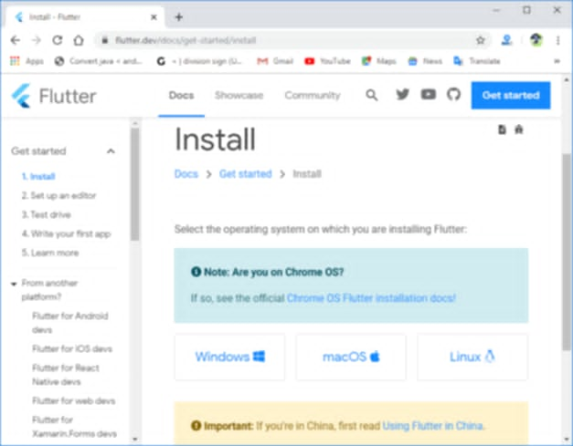In this chapter I set up my environment with the Flutter SDK and Dart, followed by creating my first Flutter project. Flutter utilizes the Dart programming language, which is included in the Flutter SDK. First step is I need to install the Flutter SDK, which will automatically include Dart. Once I have the SDK installed, i can create now a new Flutter project using my chosen IDE (like Android Studio or VS Code). This project will contain the necessary files and folders to begin writing my Flutter app. Within this project, I’ll write Dart code to build the UI using Flutter's widget system. Flutter offers a rich set of pre-built widgets for common UI elements, and i can also create custom widgets. I also need to manage state (data that changes over time) in my app, which can be done using various techniques like setState, Provider, or BLoC. Once i have my code written, I can run and debug your app using Flutter's hot reload feature, which allows me to see changes in your app instantly without restarting it. Finally, i can build and deploy my app to the desired platform (Android, iOS, web, or desktop).